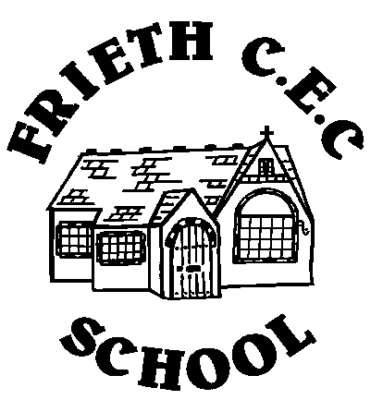
Frieth CEC School
Frieth
Henley-on-Thames
Oxon RG9 6PR
01494 881554

01494 881554
Developing Potential without Limitations

Wednesday 12th October 2016
WHOLE SCHOOL MEETING
Dear Parents/Guardians,

Each year we organise evenings whereby the Governing Body and teaching staff have the opportunity to feedback to parents on the progress of both the previous and new initiatives within the school.

This term we have set aside Wednesday 2nd November at 7:30pm to join together as a school. We will be presenting information on the following areas:
- Maths and Assessment
- Academisation - what are we doing?
- British Values – How are we interpreting it at Frieth? What does it mean for our school and children?
- SDP review of 2015-2016 and new priorities for 2016-2017
- Celebration! Sharing our successes this year!

To further entice you to the evening, snacks and drinks will be available.

Please indicate on the reply slip your attendance at the evening, and return it by Wednesday 19th October 2016

Yours truly

Mrs Merelina Tebbot Mrs Jo Reid
(Chair of Governors) (Headteacher)

Wednesday 2nd November at 7:30pm

Child’s Name:____________________________ Class_____________________

___________people will be attending (Please complete with a number)

Signed:________________________________________________

