Amazing Fact
Snowmen

No one really knows when the first snowman was made, but the first photograph of a snowman was taken in 1953.

Christmas Challenge
Can you follow the instructions to create your own snowman?

Instructions
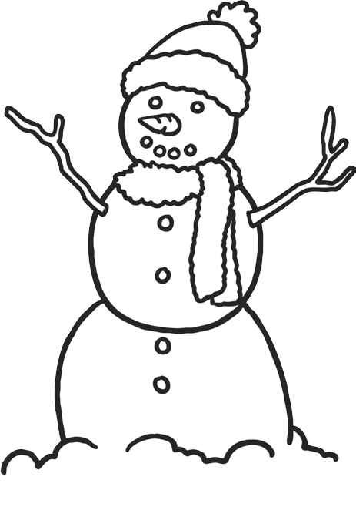
- Draw two triangular eyes onto your snowman.
- Colour the left eye in blue.
- Colour the right eye in green.
- Draw a black circle as a nose.
- Draw five small black circles to make his mouth.
- Draw five buttons down the snowman’s tummy.
- Colour the middle button in red.
- Colour the top button in yellow.
- Colour the bottom button in purple.
- Colour the other two buttons in orange.
- Draw a hat on the snowman’s head and colour it in using red and green stripes.
- Draw two arms on the snowman and colour them in brown.
Challenge for Yr 1 & Yr 2
You could also try to find out:
- what unusual thing the people of Zurich do with their snowman;
- where the world’s largest snow sculpture was made;
- which 3D shapes are found on a snowman;
- if a snowman would melt quicker if it was wearing clothes.
Challenge for Yr 2
You could write a report about Snowmen based on your research to present in class.

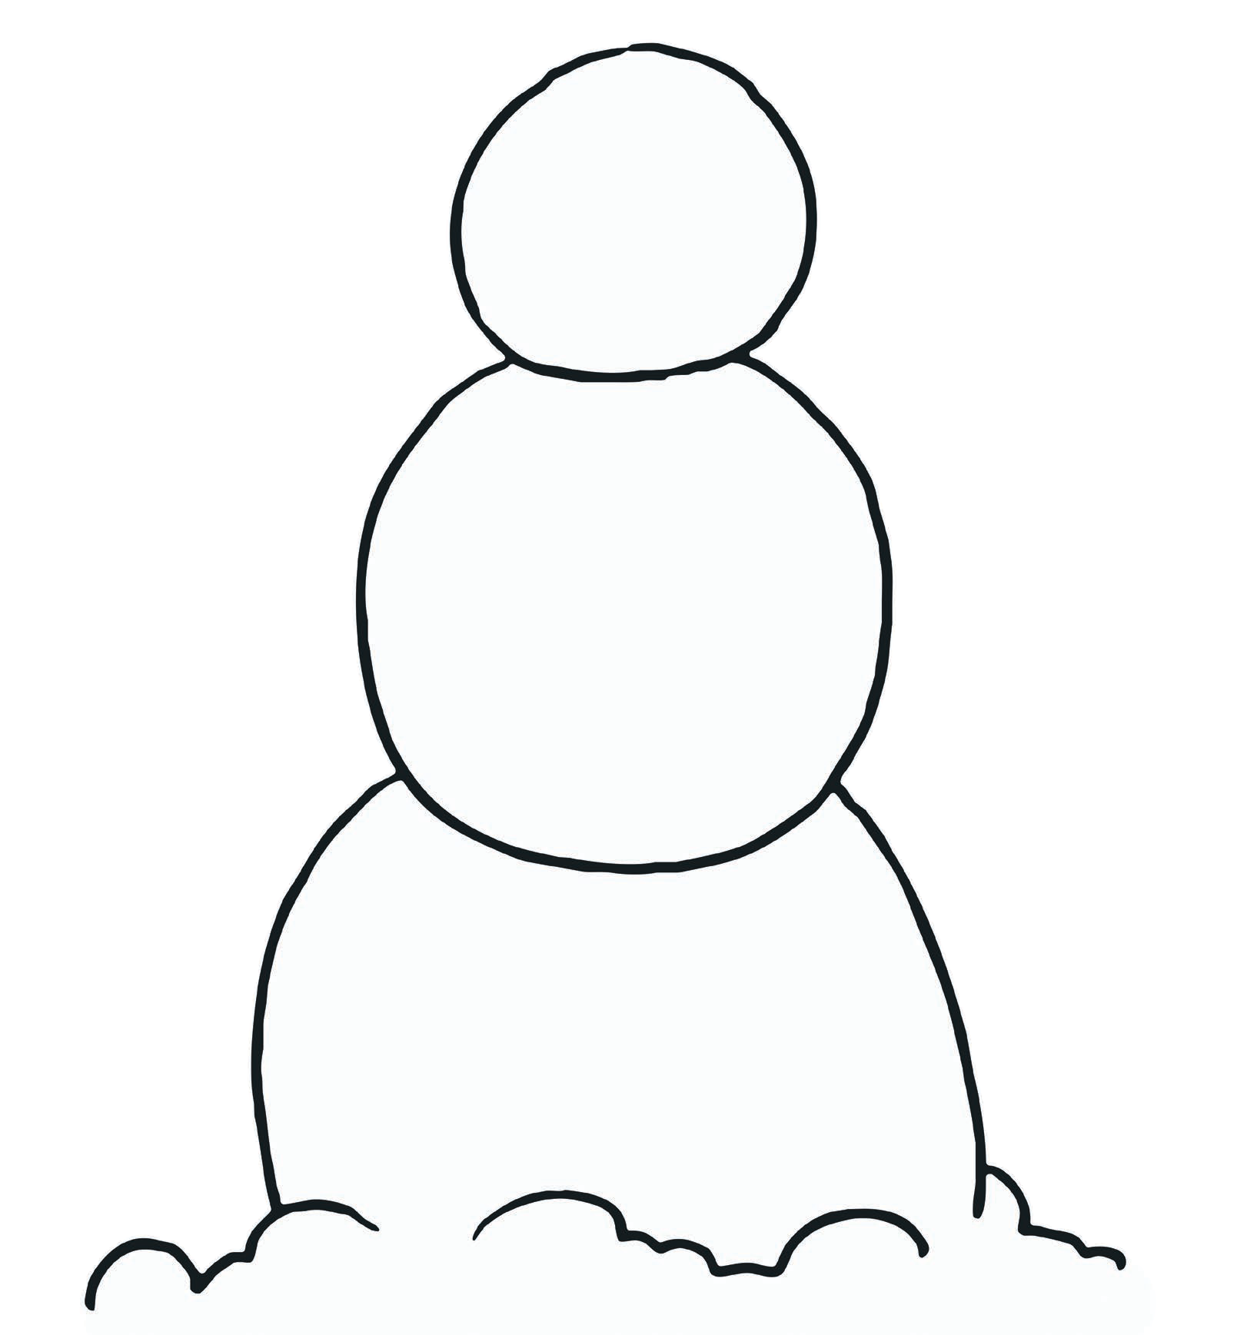
My Snowman

