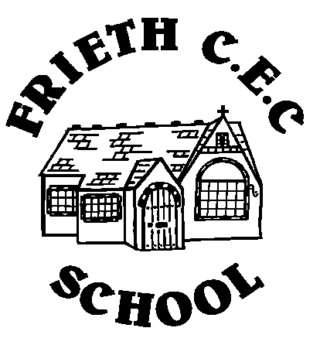
Frieth CEC School
Frieth
Henley-on-Thames
Oxon RG9 6PR
01494 881554

01494 881554
Developing Potential without Limitations

19th February 2018

Dear Parents,

WORLD BOOK DAY THURSDAY 1st MARCH 2018

As you already know, on Thursday 1st March we celebrate World Book Day. We would like the children to come to school dressed as their favourite book character and to bring their book to school.

Many thanks

Mrs K Tyzack

