Kites Class Year 4
Day | Maths | English | Other
Mon 18.5.20 | Please then go to WHITE ROSE Planning for Week 4 of The Summer Term and follow Lesson 1.  On their website this is marked wc11.5.20 SUMMER TERM WEEK 4  https://whiterosemaths.com/homelearning/year-4/  UNFORTUNATELY, THEY HAVE PUT THE RESOURCES ON SUBSCRIPTION. THESE HAVE BEEN DOWNLOADED, INCLUDING THE ANSWER SHEETS AND YOU’LL SEE THEM IN THE MATHS RESOUCES BLOCK ON THE CLASS PAGE.  For more challenges, look for your activities in MATHLETICS (please attempt on of the PROBLEM SOLVING challenges at the foot of your page), PURPLE MASH GAMES or of course TT ROCKSTARS where you can try to improve you score and/or speed in a SOUNDCHECK. Around half of you have done a SOUNDCHECK in the last week and many of you have improved your personal best. I’d like everyone to do a SOUNDCHECK this week even if your best score is already 25/25  We have also found this website that has loads of free maths games on it. It covers a wide range of age groups so it’s important that you find something that is a challenge as there is no point in just play baby games!!  https://toytheater.com/category/math-games/  This is one of the many games there. It looks really easy but it gets harder quite quickly ..see how many levels you can get to!  https://toytheater.com/multiply-race/ | Spelling This week you are looking at words with the prefix non  non-stick  non-stop  non-starter  non-smoker  nonsense  non-fiction  non-drip  non-violent  I have attached the Year 4 Spelling A4 Poster  Look through the power point presentation. It will help you understand the spelling pattern.  Then complete your workbook - spelling booklet 3A week 5  Challenge – Do the word chart activity sheet  Handwriting – Practise writing the words using a cursive script.  Open the Handwriting sheets | Art The artist Andy Warhol has used popular images in his artwork. Look at his ‘Campbell’s Soup’ images. He selected this image because it was a popular choice of food for his for lunch. 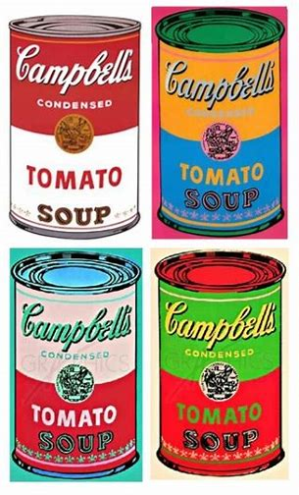  What do you like for lunch?  Today you are going to take a label, rework and overwork it in the style of Warhol. (see also Warhol’s ‘Jagger’ portraits to explore further ideas for overworking an image). 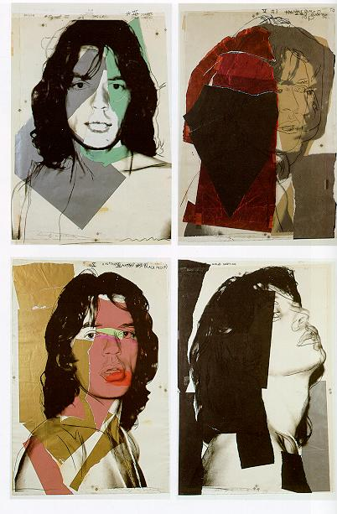  Work over the selected labels etc and extend to form a unique image. You can see that they stuck the label or wrapper onto the sheet of paper and then drew/painted around it. Here are some examples of work that other children produced when overworking a label. 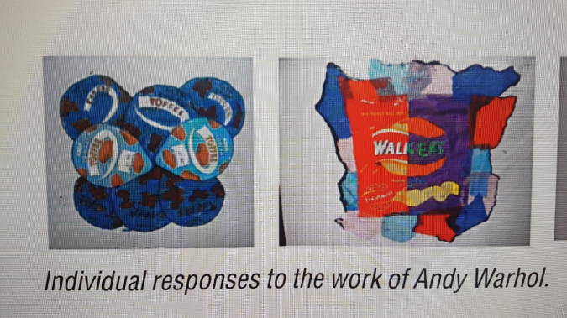  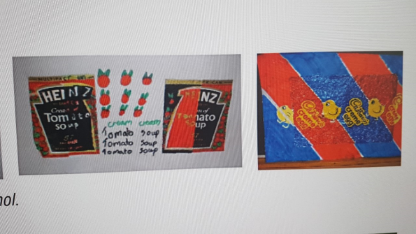  Please send in examples of your work. I would love to see them.
Tues  19.5.20 | Please then go to WHITE ROSE Planning for Week 4 of The Summer Term and follow Lesson 2.  On their website this is marked wc11.5.20 SUMMER TERM WEEK 4  https://whiterosemaths.com/homelearning/year-4/  UNFORTUNATELY, THEY HAVE PUT THE RESOURCES ON SUBSCRIPTION. THESE HAVE BEEN DOWNLOADED, INCLUDING THE ANSWER SHEETS AND YOU’LL SEE THEM IN THE MATHS RESOUCES BLOCK ON THE CLASS PAGE.  See notes above on additional challenges and resources such as MATHLETICS, PURPLE MASH and TT ROCKSTARS | Reading  This week I have set the next part of your work on Purple Mash which continues on with the book you were reading. There are activities to do connected with that book. These activities include comprehension and extension work that we would normally carry out in our reading sessions. Some of you haven’t read the first 3 chapters from last week so you will need to take a look at these.  I really enjoyed the conversations that some of you wrote last week and look forward to reading the work you produce this week as a result of your reading. | PSHE  In PSHE this week you are going to be looking at making decisions. There is a PowerPoint which gets you to think about this and there are 2 resources that you can use.  See attachments 19.5.20 PSHE.
Wed  20.5.20 | Please then go to WHITE ROSE Planning for Week 4 of The Summer Term and follow Lesson 3.  On their website this is marked wc11.5.20 SUMMER TERM WEEK 4  https://whiterosemaths.com/homelearning/year-4/  UNFORTUNATELY, THEY HAVE PUT THE RESOURCES ON SUBSCRIPTION. THESE HAVE BEEN DOWNLOADED, INCLUDING THE ANSWER SHEETS AND YOU’LL SEE THEM IN THE MATHS RESOUCES BLOCK ON THE CLASS PAGE.  See notes for 18.5.20 above on additional challenges and resources such as MATHLETICS, PURPLE MASH and TT ROCKSTARS | Grammar - In grammar today you are going to go over the use of co-ordinating conjunctions.  Go to the following link  https://www.bbc.co.uk/bitesize/articles/zk68wty  To identify similes and metaphors and be able to use them in your writing.  This lesson includes:  - two videos to help you understand similes and metaphors  - four activities  You will be using these skills when you write character descriptions tomorrow. | SCIENCE - INVESTIGATING TOOTH DECAY  Today’s science lesson continues our unit on ANIMALS INCLUDING HUMANS, follows on from last week’s work on the different types of teeth and looks at the important matter of tooth decay. There is a powerpoint to follow through and an investigation to begin which suggests putting a hard-boiled egg in each of four different liquids to see what happens after a number of days. Your parents might well feel this is a waste of eggs so you could either do it with just three eggs and choosing water as one of your liquids.  There are two activity sheets where you should describe your INVESTIGATION and another where you should make PREDICTIONS about what you think will happen to each of our eggs in the different liquids  You might also like to look at the BBC Bitesize clip on this subject  https://www.bbc.co.uk/bitesize/clips/znrb4wx  For a challenge you could create a poster (either by drawing or digitally using word. Powerpoint or even Scratch) stating the importance of healthy teeth.
Thurs  21.5.20 | Please then go to WHITE ROSE Planning for Week 4 of The Summer Term and follow Lesson 4.  On their website this is marked wc11.5.20 SUMMER TERM WEEK 4  https://whiterosemaths.com/homelearning/year-4/  UNFORTUNATELY, THEY HAVE PUT THE RESOURCES ON SUBSCRIPTION. THESE HAVE BEEN DOWNLOADED, INCLUDING THE ANSWER SHEETS AND YOU’LL SEE THEM IN THE MATHS RESOUCES BLOCK ON THE CLASS PAGE.  See notes for 18.5.20 above on additional challenges and resources such as MATHLETICS, PURPLE MASH and TT ROCKSTARS | Writing  Last week you started to think about the characters who feature in a myth and you made up two of your own characters – a hero/heroine and a mythical character.  Today I would like you to write a detailed description of both of these characters. I would like every sentence to be carefully thought out. How will it begin? I don’t want sentences which always begin with he/she, so think carefully about the potential use of fronted adverbials etc.  - describe the character’s appearance  - describe the character’s background/past  - describe how the character speaks  - describe how the character moves  - describe the character’s actions, thoughts and feelings  - describe the character’s personality  - include figurative language (metaphors and similes) to enhance your description e.g. His heart swelled with a sea of tears, her whining voice sounded like the screech of an untuned violin.  Then I would like you to think about the setting. Take a look at the setting poster. See attached for different ideas.  Write a paragraph about your setting.  Tomorrow you will be planning your story. | ANCIENT GREEKS – OLYMPICS  For our topic work this week we will continue or learning about the Ancient Greeks and in particular one of their traditions that we still enjoy today if not perhaps this year. Yes, the Olympic Games. There’s a power point to look through and then an activity where you look at the different events in an Ancient Greek Olympics and compare it with those in today’s games.  You might find this link to the icons for the different events in what would have been this year’s summer games in Tokyo a bit more interesting that the ones on the work sheet or you might like to find or create your own.  https://maxcdn.icons8.com/app/uploads/2019/03/pictograms-tokyo-design.jpg  Once again for a challenge or as an alternative you could make a comparison using your computing skills. A Power Point presentation or a Word document of course incorporating some pictures.
Fri  22.5.20  INSET DAY | For maths today you can have a go at solving the mystery. It’s called Murder at the Movies. You have use your maths skills to solve the clues to eliminate the suspects to work out who is the culprit. Have fun and good luck! The last pages have all the answers so don’t spoil the fun by peeping too early!! | Writing  Today you are planning your myth story ready to write it after the half term break.  A myth is a story used to explain why things are the way that they are in the world around us. Some myths have survived for thousands of years.  To plan your story take a look at the planning document attached to give you ideas of the sections needed. Remember a plan does not need to be written in whole sentences and should not be the actual story. The plan needs to give you key words that will help trigger the idea for what you need to write when you are actually doing the whole story. If I had written the words fire and escape in my plan it would help me know that when I write the story after half term I will write about when the characters escape from the burning flames of the fire. | COMPUTING  Use this link to the Hour of Code website where you’ll find this SCRATCH activity to animate your name. You don’t have to do your name, you could choose any word, a favourite food, football team or celebrity..  https://scratch.mit.edu/projects/editor/?tutorial=name

