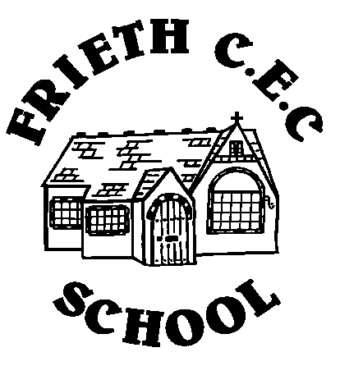
Frieth CEC School
Frieth
Henley-on-Thames
Oxon RG9 6PR
01494 881554

01494 881554
Developing Potential without Limitations

Friday 10th November 2017
Dear Owls Class Parents/Carers,

RE Staffing in Owls

There will be a change in staffing for Owls class from next week. Owing to an extremely serious medical emergency for a very close family member, Miss Gibbens will be flying home to Canada this weekend to be with her family. I know that you will all understand that at times like these, family are the priority and keep Miss Gibbens and her family in your thoughts.

Initially we have arranged for Mrs Thackery to join the staff as the temporary Owls class teacher. She has spent the day in school today with Miss Gibbens to get to know the children and to have some handover time. While she is away, Miss Gibbens will continue to provide planning and this will be overseen by Mrs Reid.

We are incredibly lucky to have excellent, experienced Early Years support staff in school who will remain with the class and ensure the routines remain unchanged to provide as much continuity for the pupils as possible.

Thank you for your understanding.
Yours sincerely

Mrs Jo Reid
Headteacher

