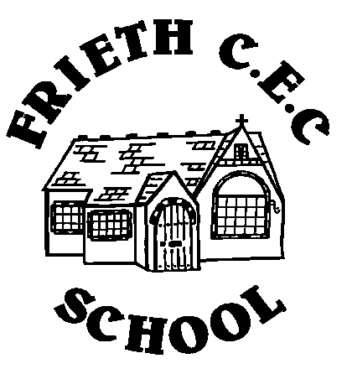
Let your light shine!
Special Amendments to Behaviour Policy
During Covid-19 Epidemic
Rationale
At Frieth CEC School our aim is to shine a light on individual success and open the doors to our future global citizens by developing potential without limitations within a welcoming Christian and spiritual community. Our values of respect, responsibility, resilience, honesty, kindness and creativity guide all that we do, including our behaviour guidelines and choices, so every child can feel nurtured, supported and safe. Additional support has been made available to pupils to support their good mental health.

Behaviour Principles
In light of the need for children to behave differently and to follow specific rules on their return to school during the Covid-19 epidemic, this amendment to our Behaviour Policy outlines specific changes to guidance that pupils will have to follow. Our sole guiding principle when making any changes or adjustments to policy is to be able to keep all of our children, families and staff safe and place their wellbeing at the forefront of everything we do. These amendments will be communicated to pupils, parents and staff.

Changes to Behaviour Expectations:
- We have amended expectations for breaks or playtimes, including where children may or may not play (for example when they can use equipment within their ‘bubble’.)
- We have clear rules about coughing or spitting at or towards any other person – this could lead to sanctions at the discretion of the headteacher.
- We have new rules for social distancing which must be followed.
- Amendments to our ‘acceptable use agreements’ relating to conduct at home in the light of pupils using our remote learning platform TEAMS.
​​​​​​​
Changes to Routines and Procedures:
- The requirement to follow any altered routines for arrival or departure.
- The requirement to follow changes to timetabling, including use of toilets, hall and equipment.
- Following instructions on who pupils can socialise with at school.
- Following rules about seating and sharing any equipment or other items.
- Changes to reward systems due to having no whole school gatherings (ie: Celebration Assembly).

Hygiene and Health Expectations:
- The requirement to follow school instructions on hygiene, such as hand washing and sanitising.
- Higher expectations about sneezing, coughing, use and disposal tissues (‘catch it, bin it, kill it’) and avoiding touching of face.
- Expectation to tell an adult if you are experiencing any symptoms of coronavirus.

