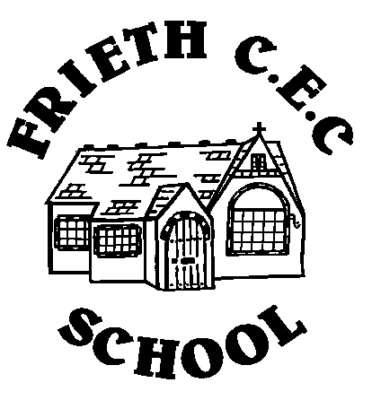
Frieth CEC School
Frieth
Henley-on-Thames
Oxon RG9 6PR
01494 881554

01494 881554
Developing Potential without Limitations

5th September 2016

Dear Parents/Guardians

CLUBS AUTUMN TERM 2016

Please find attached a summary of the clubs running in the autumn term. Please explain to your child that if they sign up for a club they are expressing a preference to be part of the club for the entire autumn term.

In order to book onto a club please:

1. Complete one permission slip per child, per club ; please note that we need a Frieth School permission slip completed for all clubs whether they are run by school or an outside provider.

2. Return your slips by Thursday 8th September to the school office via your child's bookbag.

3. Please include payments for Tuesday- Judo, Art and Street Dance and Thursday -Art club with your permission slip - make cheques payable to 'Frieth CEC School' as explained on the club summary.

4. Any clubs highlighted in yellow please book and pay direct with the company running the club, letters are attached. Please remember to complete a Frieth School club permission slip for these clubs too and return it to the school office.

Club places will be allocated on a ‘first come, first served basis unless your child has been placed on a waiting list from the previous term. You will receive a slip home at the start of next term to confirm which clubs your child has been allocated a place.

The club information will also be available on the school website.

Kind regards

Anna Houghton
Administrative Officer
Frieth C.E.C. School
01494881554

