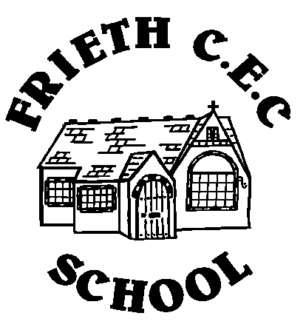
Frieth CEC School
Frieth
Henley-on-Thames
Oxon RG9 6PR
01494 881554

01494 881554
Developing Potential without Limitations

20th November 2017

Dear Parent/Carer,

SWIMMING – 21st NOVEMBER 2017

The swimming lesson planned for the children tomorrow, 21st November will be a ‘Survival and Safety Swimming’ session.

The children should bring a 2 piece cotton pyjama set or similar with long sleeves and full length bottoms (no onesies). We would be grateful if you could ensure that they bring this with them as well as their standard swimming kit on the 21st. We suggest they have a plastic bag to put the wet PJ’s in.

Best Regards

Nigel Honey
Class Teacher

