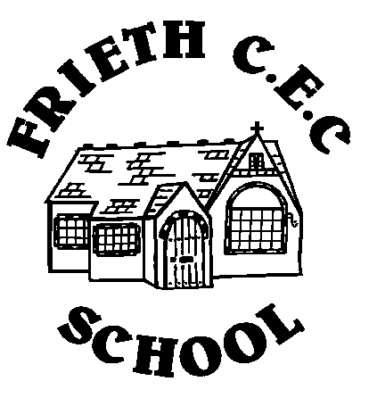
Developing Potential without Limitations

Year 1 Phonics Check
Parent Information
At school we are starting to familiarise the year 1 children with the resources used in the phonics check in June.
The check consists of a combination of real words and pseudo words. Pseudo words are included because they will be new to all pupils and therefore test phonic decoding skills without reliance of knowledge of words encountered previously or from visual memory. These words are presented with a picture prompt so pupils recognise they are a pseudo word they have not come across before.
The check is divided into two sections. There are some practice words provided at the start, which are not scored, in order to familiarise pupils with the structure of the check and to ensure they understand what they are required to do.

Section 1 contains 20 words comprising of 8 real and 12 pseudo words. The words are made up of a selection of the more common grapheme-phoneme correspondences and consist of a variety of phonological structures, for example:

- CVC words such as tip, moon, bell
- VCC words such as act, imp
- CCVC words such as pram, crack, sweet
- CVCC words such as tent, roost, chimp

Section 2 contains a total of 20 words comprising of 12 real and 8 pseudo words. The words will contain some more advanced grapheme-phoneme correspondences and include additional phonological structures to those included in Section 1, for example:

- CV words such as hair, pay, thigh
- CVC words such as head, shake, bowl
- CCVC words such as stove, plain, thrush
- CVCC words such as paint, roast, found
- CCVCC words such as frost, steams, shrink
- CCCV words such as screw, stray, splay
- CCCVC words such as scrape, strum, splat
- CCCVCC words such as strict, sprint, splits

It also includes 4 two-syllable words, containing a variety of grapheme configurations, between 5 and 8 letters in length, for example music, velvet, machine, farmyard.
The pseudo words will be grouped together in each section.

There is also a good link to a parent video tutorial which explains the check with examples.
http://www.ruthmiskin.com/en/resources/parent-tutorial-phonics-screening-check/

To support your child at home, we have prepared Phonics Reading Practise Sheets which are attached to this information. Please read through them regularly with your child, preferably daily, to ensure the knowledge of the sounds is embedded fully. Other ideas for activities are:
- How many other words can you find with the ay phoneme? With the ou phoneme? Etc…
- Make a list on the fridge and read them every day.
- Use bath crayons and write some of the words during bath time
- Do some baking and make words in the flour using their fingers
- Turn the sheet into flashcards and time how quickly your child can read the words in any order
- Practise sounding out the phonemes using the sound buttons before blending the words
- Log on to the following websites to play games to support their phonics knowledge. Try to play the phase 5 games.
  - Education City
  - Phonics Play
  - https://www.phonicsbloom.com
  - https://learn.readwithfonics.com/school/phonics-games?phase=5
  - https://www.topmarks.co.uk/english-games/5-7-years/letters-and-sounds

