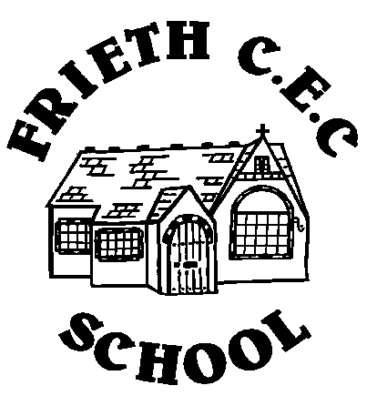
Frieth CEC School
Frieth
Henley-on-Thames
Oxon RG9 6PR
01494 881554

01494 881554
Developing Potential without Limitations

Wednesday 12th July 2017

Dear Parents/Guardians

CLUBS AUTUMN TERM 2017

Please find attached a summary of the clubs running in the autumn term. Please explain to your child that if they sign up for a club they are expressing a preference to be part of the club for the entire autumn term.

In order to book onto a club please:

- Complete one club booking slip per child per club; please note that we need a Frieth School club booking slip completed for all clubs whether they are run by school or an outside provider.
- Make any bookings with outside providers direct with the provider as per their booking letter. All booking letters are attached.
- Return your slips by Friday 8th September to the school office via your child's bookbag.
- Any clubs highlighted in yellow please book and pay direct with the company running the club, letters are attached. Please remember to complete a Frieth School club permission slip for these clubs too and return it to the school office.

Club places will be allocated on a ‘first come, first served’ basis unless your child has been placed on a waiting list from the previous term. You will receive a slip home to confirm which clubs your child has been allocated a place.

The club information will also be available on the school website.

Kind regards

Mrs J Reid
Headteacher

