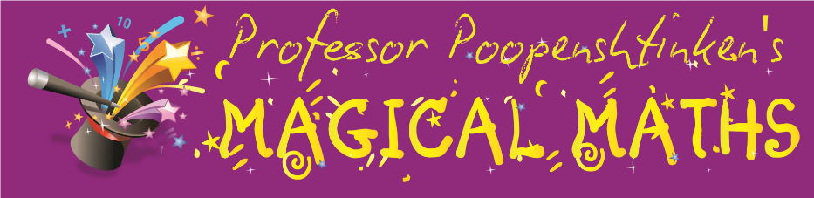

**Magical Maths is coming to Frieth CoE Combined School**

Magical Maths is a super fun after school club designed to boost children’s confidence and better engage them with maths.

The club runs for an hour a week after school starting Wednesday 14th September and will run for 6 weeks. Each week has a different theme and includes a dressed up character including Professor Poopenshtinken (maths genius), the Mathmagician, Stately Holmes (the maths detective) and the Olympic Mathletes!

For more information and to sign up, visit: **www.magicalmathsclub.com**

Or call

**01494 854443**

**Places are limited so sign up quick!**