No child should suffer harm, either at home or at school. Everyone who works in our school has a responsibility to make sure that all our young people are safe.

This leaflet has been given to you to make sure you understand what is expected of you. Please ask the person who gave it to you if you are not clear about anything in it, and keep the leaflet in a safe place, so that you can read it again if you need to.

If you are worried about the safety of any young person in your school, you must report this to the person Designated for Child Protection in your school.

Developed by Bucks County Council
Education Safeguarding Advisory Service

Useful Contacts

Headteacher:
Mrs Jo Reid
______________________

Designated Safeguarding Lead
Mrs Jo Reid
Mrs Krisztina Tyzack
Mrs Lorna Sparks
01494881554
______________________

Chair of Governors:
Mrs Merelina Tebbot
______________________

Education Advisory Service

Education Safeguarding Advisor:

Therese McAlorum 01296 382912

LADO

01296 382070

First Response Team advice/referral social care
0845 4600 001

Child Protection Advice for
Volunteers

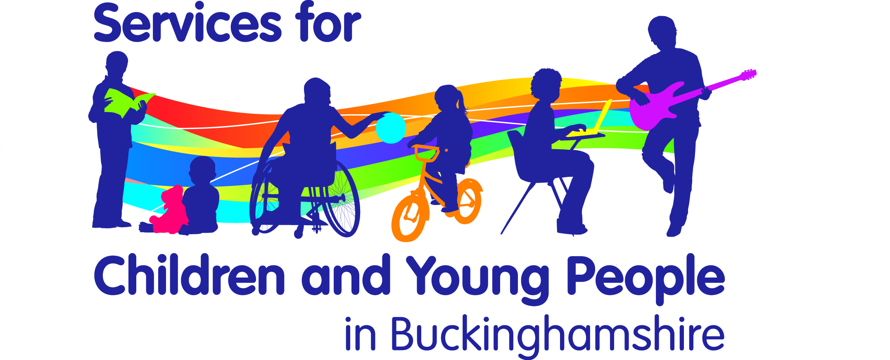

Child Protection Advice for Volunteers

Thank you for your interest in becoming a volunteer. This leaflet is designed to provide some useful advice.

As a school we are committed to Safeguarding and meeting the needs of children, young people. This leaflet will provide some useful advice and information when working with children whilst you are with us.

Disclosure and Barring Service (DBS) checks

Part of Schools safeguarding policy requires Volunteers working in a “ Regulated Activity” i.e. working with children ”frequently”, “intensively” or overnight and are unsupervised will undergo an enhanced DBS check ( this replaces the old CRB) . This is just to help ensure that unsuitable people are prevented from working with children. The Head teacher will be able to advise you further on this and tell you more about their school code of conduct.

If you have already had a DBS check completed you should notify the Head teacher who can consult with the HR team to determine whether a repeat check is necessary.

Whilst you are waiting for the checks to be completed it is very important that you are not left to work with children or young people without supervision of a member of the school staff.

You should also inform the Head teacher immediately if you become subject to any criminal investigation, caution or conviction. This helps to protect you as well as the young people in your care.

What are my responsibilities as a Volunteer?

All those who come into contact with children through their every day work whether paid or voluntary have a duty to safeguard and promote the welfare of children. It is important to be familiar with our Child Protection Policy a copy of this document will be given to you during your induction.

Which children need protection?

You may become aware whilst working with a child that there are some problems at home or elsewhere that give you cause for concern.

You may become aware of unexplained marks or bruising, or changes in the child’s behaviour or demeanour

Sometimes children display aggressive behaviour, become withdrawn and uncommunicative or unable to concentrate. These may be out of character for the child

What should I do if I am worried about a child?

We have a Designated Safeguarding Lead who has been trained to support students and staff when concerns arise.
Name – Mrs Jo Reid
Contact details 01494881554
You must report your concerns to them without delay. They will support you to take the appropriate action to safeguard the child concerned
Remember safeguarding is everyone’s responsibility

What should I do if a child discloses that s/he is being harmed?

Although the likelihood of this is small it is important to know what to do in such an eventuality.
Listen to the child, without making judgements.
Take what they tell you seriously, children rarely lie about such matters.
Explain that you can’t keep the information secret and must pass it on to someone who will know what to do.
Don’t interrogate the child and ask leading questions, such as “what did he do next”.
Try and convey to the child that they are not to blame for what has happened, though at the same time avoid criticising the abuser.
Don’t make promises that you can’t keep but tell the child what you are going to do.

What should I do next?

Speak with the Designated Safeguarding Lead immediately

What should I do if the alleged abuser is a member of the school staff?

You should report such allegations to the Head teacher. If the allegation is about the Head teacher contact the Chair of Governors.

How do I assure that my behaviour is always appropriate?

Appropriate relationships with children should be based on mutual trust and respect.

You will be given a copy of our school Code of Conduct which sets out the behaviours we expect of all staff and volunteers. You must read and be familiar with this document

As a volunteer you may well be working closely with children sometimes on a one to one basis.
Children, especially when they are young are often spontaneously affectionate and tactile and it is important not to alienate them through lack of response or by appearing to reject this.

If you are working with a pupil on his/her own always ensure that the door is left open or that you are visible to others.

Never make arrangements to meet a pupil on their own without school and parental permission.

Do not photograph pupils, exchange e-mails or text messages, or give out your own personal details.

